MONTHLY TEST- JULY-2019
Marks obtained:

Total:
30
Name: _____________
Grade: II Section___
Subject: EVS
Date: 29.1.7.19
Time: 1 Hour

I. Dictation. (5x1=5)
1. ________________
2. ________________
3. ________________
4. ________________
5. ________________
II. Fill in the blanks. (5x1=5)
6. During _______________, we meet friends and relatives, and greet each other.
7. Rhea shares __________ and food with her neighbours.
8. People live next to each other are ________________.
9. ______________ gets scared to hear noise of fire crackers.
10. ___________ is an outdoor game.

III. Match the following. (5x1=5)
11. Grandfather Mother
12. Uncle Niece
13. Father Grandmother
14. Nephew Sister
15. Brother Aunt
IV. State whether the sentences are true or false. (4x½=2)
16. Older people in the family may need a lot of a care and help.
17. During diwali, we light lamps and make sweets.
18. A family is not made up of people who are closely related to each other.
19. Rhea lives with her grandparents.
V. Create a poster to welcome a new friend to your class. (3)

VI. Answer the following (3x2=6)
20. What is a nuclear family?
____________________________________________________________
____________________________________________________________
____________________________________________________________
21. Name any two festivals which is celebrated by all the groups of people in India.
____________________________________________________________
____________________________________________________________
____________________________________________________________
22. Give any two examples of indoor and outdoor games.
____________________________________________________________
____________________________________________________________
____________________________________________________________
VII. Name the festivals and color pictures. (4x1=4)
PONGAL ,HOLI,, DIWALI, CHRISTMAS

1.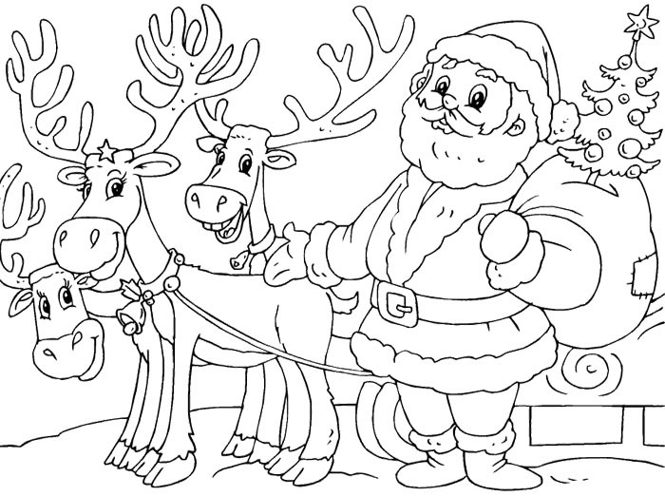 ______________________

2.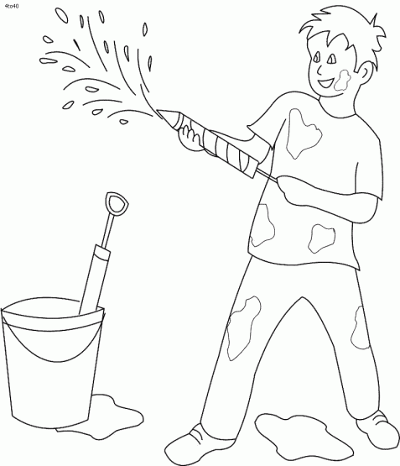 _____________________

3. _____________________
4. 

